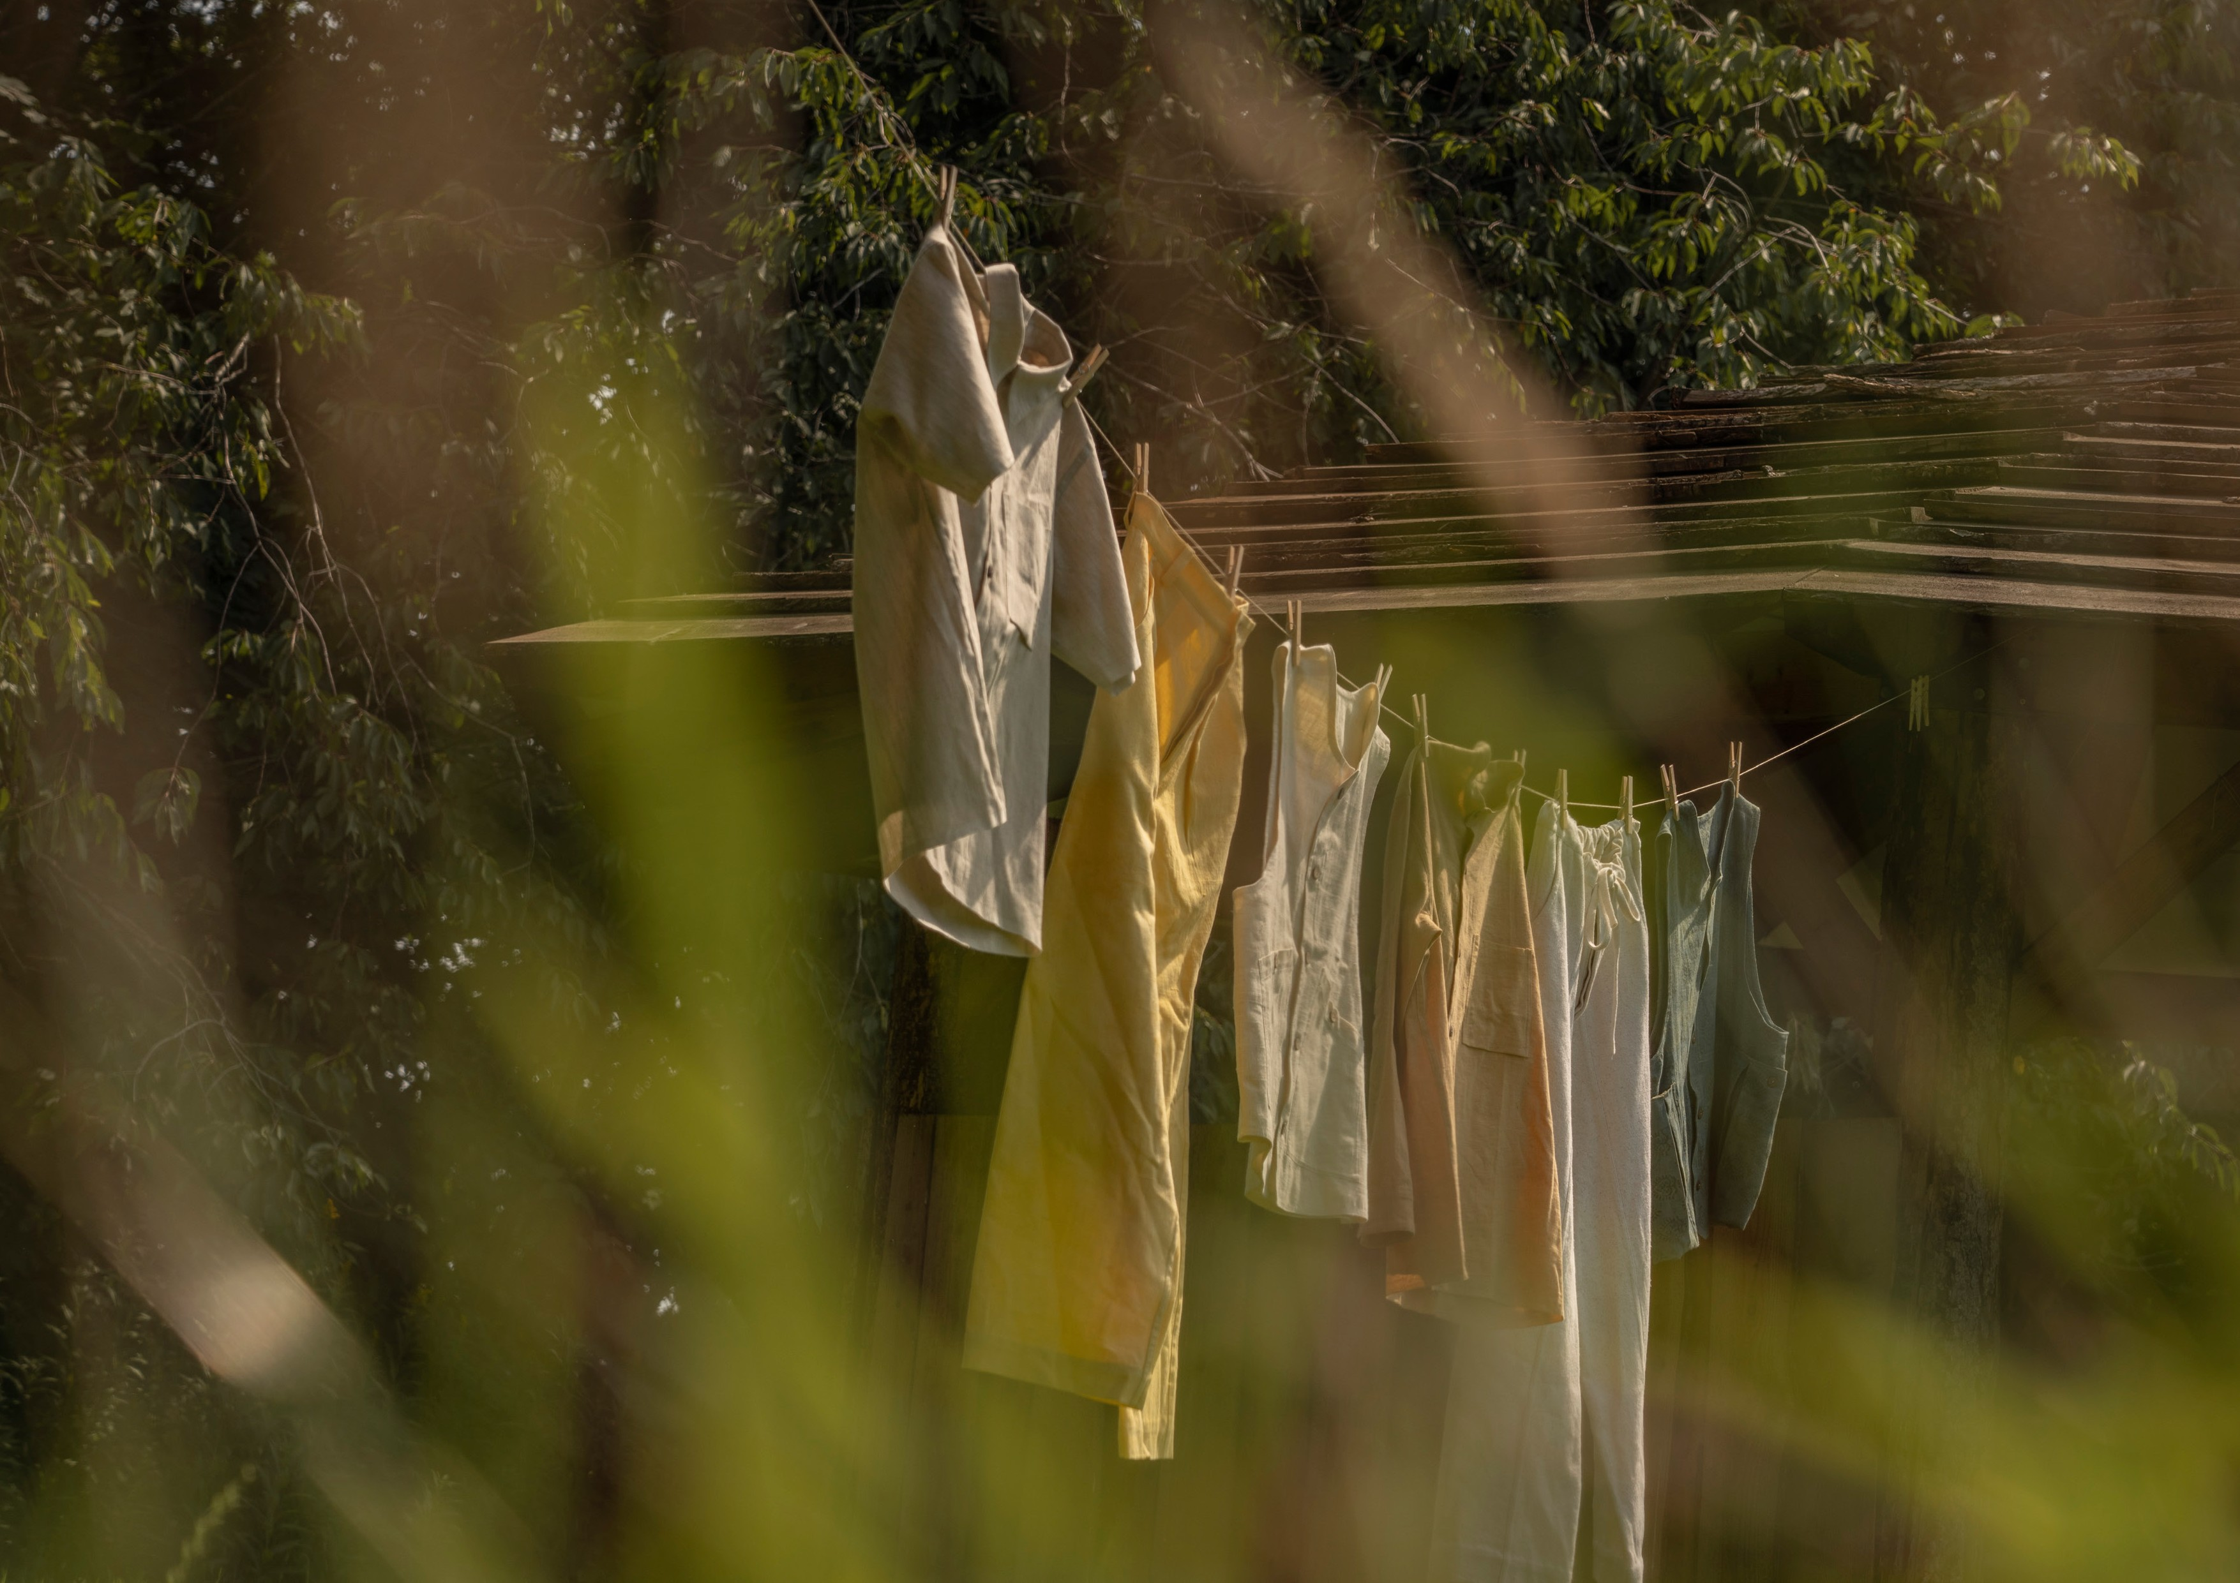
Collaborative conscious clothing
by ashna patel
The context of the project lies within the principles of a regenerative economy and proposes an alternative methodology of designing and producing garments with regenerative resources and through creative democracy.

With the intention of working more intimately with members of the value chain, the project is explored in collaboration with natural fibre activists and distributors, Khadi London. With the unravelling
destructive consequences synthetic materials have on the environment, the synergy between materiality and clothing is significant, especially when considering the intention to cultivate conscious clothing. In this respect, the intersection of textiles and clothing is prioritised, and in doing so, asks the following question:

How might makers of conscious clothing work alongside textile initiatives that are rooted in natural fibres, tradition and the well-being of their value chain?

Khadi is a natural fibre originating from India that remains a culturally significant material imbued with aesthetic, historic, social and spiritual values. Khadi distinguishes itself from being categorised as simply cotton, wool and silk through the use of a spinning wheel. Khadi continues to be produced by small-scale producers and maintains its most cherished handspun and handwoven qualities.
Working with a distributor and activists of natural fibres encouraged and developed the importance of the role of materials in clothing design and production. Through actively learning about the material’s history, story, and processing, my knowledge was translated into a deeper connection when engaging and exercising the fabric and a firm understanding that the indigenously-processed material did not harm its producers and will not harm its wearers. I feel inclined to pass this understanding onto wearers, to inspire their own conscious
engagement with the cloth, to treat it as a friend and respect its service.

The explorative project resulted in a limited series of six garments each hand-crafted from organic khadi cotton. It was a conscious decision to shift to ‘less’ as I wanted each piece to tell an individual story as well as come together to represent a larger experimental narrative.

I wish to continue this collaborative practice and work solely with organic natural fibres, closures such as coconut buttons, and natural dyeing, so garments retain the opportunity to return back to soil at the end of life. The project also explored a customised service where wearers are able to choose which fabric they would like their garment
to be made out of. I believe this option to choose a fabric draws focus to the material and allows space to tell a stronger narrative of the natural fibre. To learn and teach the importance of the fibres we choose: to be kind to your skin, to the planet and the people who brought it to life.
In the wearer’s perspective, the option to choose also contributes towards an emotional connection that can lead to garments that are cherished for a longer period of time.

I want to continue to cultivate clothing that wearers fall in love with and are cherished in their wardrobes for years to come. To do this, I will need to be able to purchase the materials such as the organic khadi cotton (that simultaneously support a healthy, balanced value
chain), and to work on developing stategies that pass the knowledge of natural fibres onto wearers (for example, detailed care labels or hosting workshops in communities).

